CANDIDATE NAME ____________________________ CLASS________
 | DUNMAN HIGH SCHOOL (SENIOR HIGH)  YEAR 6 PRELIMINARY EXAMINATION 2010
 | H2 CHEMISTRY  Paper 1 Multiple Choice | 9647/01  22 September 2010  1 hour
Additional materials:
Optical Mark Sheet
Data Booklet

INSTRUCTIONS TO CANDIDATES
- Write your name and class on this question paper.
- There are forty questions on this paper. Answer all questions. For each question there are four possible answers A, B, C and D.
Choose the one you consider correct and record your choice in soft pencil on the separate Optical Mark Sheet.
- Each correct answer will score one mark. A mark will not be deducted for wrong answer.
- Any rough working should be done in this booklet.
- You may use a calculator.
Section A

For each question, there are four possible answers A, B, C, and D. Choose the one you consider to be correct.

1 | Heating phenylethanone, C₆H₅COCH₃ with iodine and an aqueous alkali yields 12.0 g of triiodomethane. What is the mass of phenylethanone that has reacted?
 | A | 0.36 g | B | 1.80 g | C | 3.65 g | D | 7.20 g

2 | If 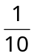mol of ethanol, 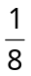mol of potassium bromide and 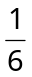mol of sulfuric acid are used to prepare bromoethane, what is the maximum mass of bromoethane which could be formed?  [M_{r} of ethanol: 46; M_{r} of bromoethane: 109]

 | A | 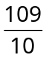g | B | 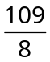g | C | 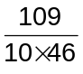g | D | 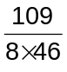g

3 | The use of Data Booklet is relevant to this question.  The successive ionisation energies, in kJ mol^{–1}, of an element X are given below.  870 1800 3000 3600 5800 7000 13200  What is X?
 |  | A | ₃₃As | B | ₅₃I | C | ₈O | D | ₅₂Te

4 | What is the electronic configuration of Ti⁺?
 | A | 1s²2s²2p⁶3s²3p⁵3d²4s²
 | B | 1s²2s²2p⁶3s²3p⁶3d²4s²
 | C | 1s²2s²2p⁶3s²3p⁶3d¹4s²
 | D | 1s²2s²2p⁶3s²3p⁶3d²4s¹

5 | BH₃ reacts with (CH₃)₃N to give (CH₃)₃NBH₃. Which one of the following will be true of (CH₃)₃NBH₃?
 | A | It is optically active.
 | B | It contains hydrogen bonding.
 | C | The B atom is electron deficient.
 | D | The B atom is tetrahedrally coordinated.

6 | Which curve shows the correct graph of pV against p for a fixed mass of an ideal gas at constant temperature?
 | A |  | 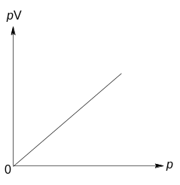 | B | 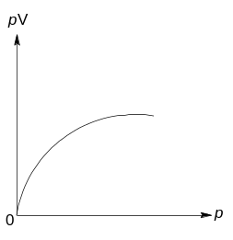
 | C |  | 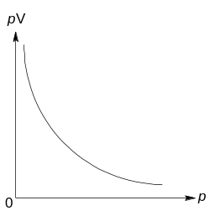 | D | 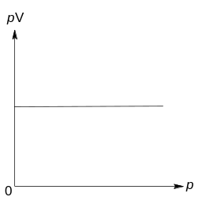

7 | Which one of the following statements is correct about a reaction for which the equilibrium constant is independent of temperature?
 | A | The enthalpy change of reaction is zero.
 | B | Its rate constants do not vary with temperature.
 | C | There are equal numbers of moles of reactants and products.
 | D | The activation energies for both the forward and reverse reactions are zero.

8 | Amyloids are insoluble fibrous protein aggregates sharing specific structural traits and are linked to various neurodegenerative diseases. The folding of amyloids into specific shape under physiological condition is a spontaneous process. What are the correct signs for ΔG, ΔH and ΔS?
 |  | ΔG | ΔH | ΔS
 | A | + | + | +
 | B | – | – | –
 | C | – | + | –
 | D | – | – | +

9 | When 13.08 g of zinc dust is added to 250 cm³ of 1.0 mol dm^{–3} aqueous copper(II) sulfate, the temperature rises by 15 °C. The specific heat capacity of the final solution is  4.20 J g^{–1} K^{–1}.  Cu²⁺ + Zn ⎯→ Zn²⁺ + Cu  What is the enthalpy change for the above reaction?
 |  | A | –4.12 kJ mol^{–1} | B | –66.3 kJ mol^{–1} | C | –78.8 kJ mol^{–1} | D | –82.9 kJ mol^{–1}

10 | A mass of 1.66 g CuSO₄.5H₂O is dissolved and added to an excess of KI(aq).  2Cu²⁺(aq) + 4I–(aq) ⎯→ Cu₂I₂(s) + I₂ (aq)  The iodine liberated is titrated against aqueous sodium thiosulfate, which is oxidised according to the following equation.  2S₂O₃^{2–} ⎯→ S₄O₆^{2–} + 2e  What volume of 0.150 mol dm^{–3} Na₂S₂O₃(aq) is required to react with the iodine liberated?
 | A | 11 cm³ |  | B | 22 cm³ | C | 44 cm³ | D | 89 cm³

11 | A sample of 1 mol of ethanoic acid is diluted at constant temperature.  Which of the following diagrams shows how the pH of the acid varies with volume V?
 | A | 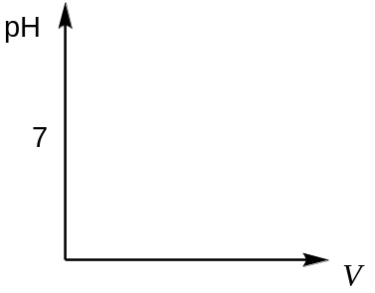 | B
 | C |  | D

12 | Public swimming pools are often chlorinated to kill bacteria. As an alternative to chlorination, silver ions can be used in a concentration of not more than 10^{–6} mol dm^{–3} and not less than 10^{–7} mol dm^{–3} of silver ions.  Which of the following compounds would, in saturated solution, provide the necessary concentration of silver ion?
 |  | compound | solubility product
 | A | AgCl | 2 x 10^{–10}
 | B | AgBr | 5 x 10^{–13}
 | C | AgIO₃ | 2 x 10^{–8}
 | D | Ag₂CO₃ | 5 x 10^{–12}

13 In the conversion of a compound Q into compound S, it is found that the reaction proceeded by way of compound R, which could be isolated. The steps involved are:
Q | slow | R | ΔH = positive
R | fast | S | ΔH = negative
Which of the following reaction profile fits these data?

 | A | 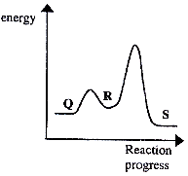 | B | 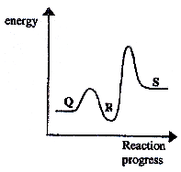
 | C | 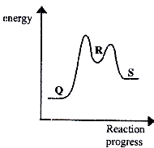 | D | 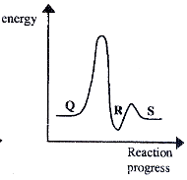

14 The half–life of a radioactive isotope P is twice that of another radioactive isotope Q. In a sample of rock, it is found that the number of atoms of Q is 4 times that of P. What will be the ratio of the number of atoms of P to the number of atoms of Q in the rock after two half–lives of P?

 | A | 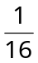 | B | 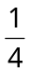 | C | 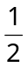 | D | 1

15 Which of the following elements forms an oxide which has a predominantly giant structure, and also forms a chloride which is readily hydrolysed?

A | barium
B | sodium
C | beryllium
D | phosphorus

16 Elements P, Q and R are in Period 3 of the Periodic Table.

  - P has the highest melting point among all the Period 3 elements.
  - The chloride of Q is neutral.
  - The oxide of R has the highest melting point among all the Period 3 oxides.

Which of the following statements is correct?

A The atomic radius increases in the following order: P < R < Q.
B The electronegativity increases in the following order: P < R < Q.
C The pH of the chlorides decreases in the following order: P > R > Q.
D The electrical conductivity increases in the following order: P < R < Q.

17 Magnesium iodate(V) undergoes thermal decomposition to yield products as shown by the equation below. The other Group II iodates(V) also undergo similar thermal decomposition.

2Mg(IO₃)₂(s) ⎯→ 2MgO(s) + 2I₂(g) + 5O₂(g)

The three graphs given below show the change in mass when 2.00 g each of three Group II iodates(V) are heated separately at a temperature T.
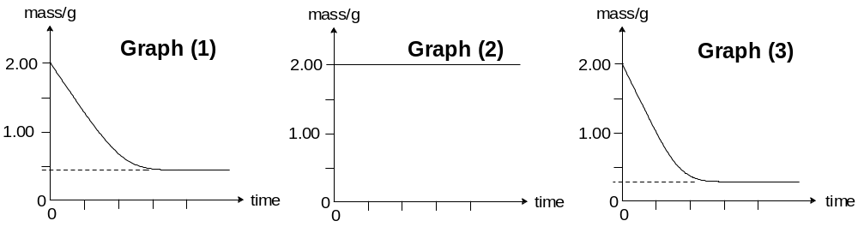
Graph (1)
Graph (2)
Graph (3)

Which three Group II iodates(V) give rise to these graphs?

 | Graph (1) | Graph (2) | Graph (3)
A | Ca(IO₃)₂ | Mg(IO₃)₂ | Ba(IO₃)₂
B | Mg(IO₃)₂ | Ba(IO₃)₂ | Sr(IO₃)₂
C | Ca(IO₃)₂ | Mg(IO₃)₂ | Sr(IO₃)₂
D | Sr(IO₃)₂ | Ba(IO₃)₂ | Ca(IO₃)₂

18 When concentrated sulfuric acid is added to separate solid samples of sodium chloride, sodium bromide and sodium iodide, which set of halogen–containing substances is produced?

 | A | HCl, Br₂ and I₂ only
 | B | HCl, HBr and HI only
 | C | HCl, HBr, HI, Br₂ and I₂ only
 | D | HCl, HBr, HI, Cl₂, Br₂ and I₂

19 Which of the following elements is a transition element and which is an element in the
s–block?
element | melting point / ºC | density / g cm⁻³ | electrical conductivity / Ω⁻¹ m⁻¹
W | 113 | 2.07 | 5.0 × 10⁻¹⁶
X | 650 | 1.74 | 2.2 × 10⁷
Y | 1744 | 11.3 | 6.0 × 10⁷
Z | 3800 | 3.50 | - × 10⁻⁸

 | Transition metal | s–block metal
A | X | W
B | Z | X
C | Z | Y
D | Y | X

20 | A compound used as optical brightener in detergents has the following formula.
 | 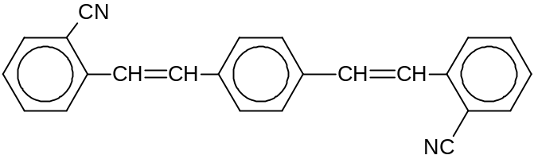
 | Which of the following is likely to be a property of this compound?
 | A | It is readily soluble in water.
 | B | The molecules exist as cis–trans isomers.
 | C | It is hydrolysed by hot dilute sulfuric acid to give an amine.
 | D | It requires 4 mol of hydrogen gas for reduction.

21 | A compound X exhibits structural isomerism, the isomers being members of different homologous series.  To which pair of isomers could X belong?
 | A | acyl chlorides and carboxylic acids
 | B | carboxylic acids and esters
 | C | amino acids and ammonium salts
 | D | amides and amino acids

22 | Hydrobromic acid reacts with ethene to form bromoethane. Which of the following is the best description of the organic intermediate?
 | A | It contains carbon, hydrogen and bromine.
 | B | It is a free radical.
 | C | It is an electrophile.
 | D | Its structure is planar.

23 | The first stage of the cumene process for the industrial production of phenol is as follows.  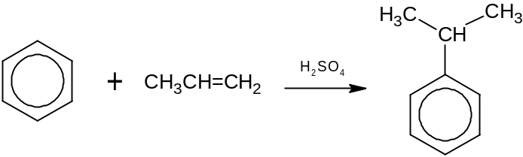  Which one of the following would be the product of reaction, under similar conditions, between benzene and cyclohexene?
 | A | 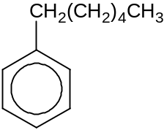 | B | 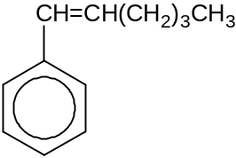 | C | 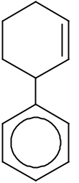 | D | 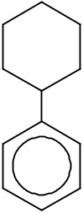

24 | Morphine is a narcotic pain reliever used to treat moderate to severe pain.  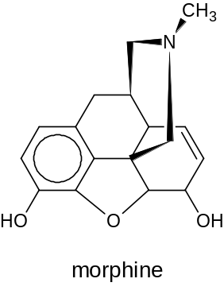  Which of the following statements regarding the reaction of morphine with chlorine in the presence of iron(III) chloride is correct?
 | A | The product formed is | 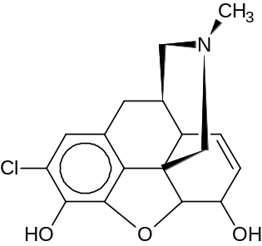
 | B | The product formed is | 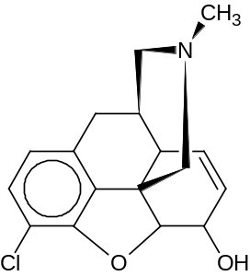
 | C | The product formed is | 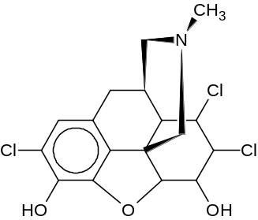
 | D | The product formed is a violet complex.

25 | Deuterium, D, is a heavy isotope of hydrogen. Deuteriobenzene is reacted with a mixture of nitric acid and sulfuric acid under suitable conditions such that only monosubstitution takes place.  Assuming that the carbon–deuterium bond is broken as easily as a carbon–hydrogen bond, which proportion of the nitrated products will be 4–nitrodeuteriobenzene?  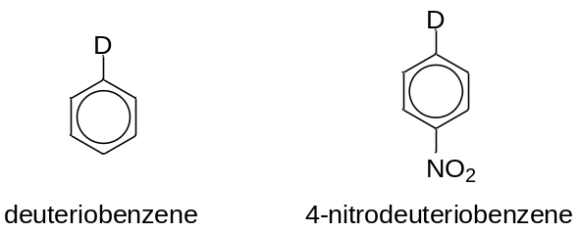
 |  | A |  | 17 % | B | 20 % | C | 33 % | D | 45 %

26 | How many alkenes (including stereoisomers) can be obtained when 2–methylpentan–3–ol undergoes dehydration?

 | A | 2 | B | 3 | C | 4 | D | 5

27 | 2,4–D and MCPA are two common selective weed killers.  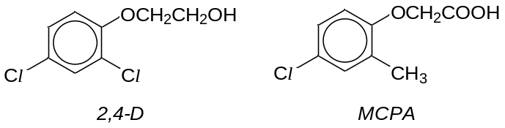  Which one of the following reagents can be used to distinguish between them?
 | A | sodium metal
 | B | phosphorus pentachloride
 | C | hot concentrated potassium manganate(VII)
 | D | hot acidified potassium dichromate

28 | The reduction of a nitrile produced a compound of formula C₃H₇NH₂. Which one of the following compounds would be produced if the same nitrile is hydrolysed by heating with diluted hydrochloric acid?
 | A | CH₃CONH₂
 | B | CH₃CH₂CO₂H
 | C | (CH₃)₂CHCO₂H
 | D | CH₃CH₂CH₂COOH

29 The Gabriel synthesis shown below gives a high yield of primary amines.

Step I
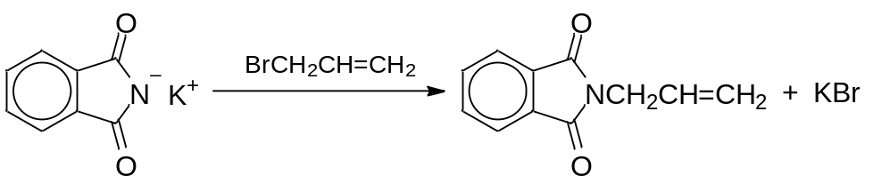

Step II
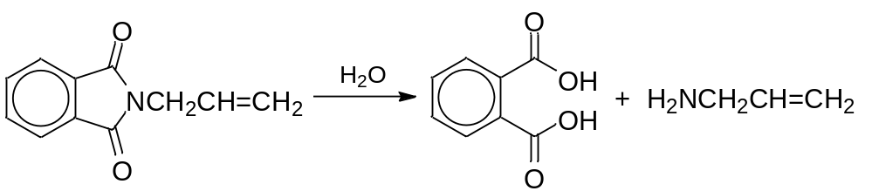

The type of reaction taking place in each of the steps is

 | Step I | Step II
A | nucleophilic substitution | hydrolysis
B | electrophilic substitution | hydrolysis
C | nucleophilic substitution | oxidation
D | electrophilic substitution | oxidation

30 Which reaction yields a carbon compound incorporating deuterium, D?
[D = 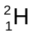]

NaOD

D₂O
A CH₃CH₂CN

D₂SO₄

H₂O, heat
B CH₃COOCH₃

D₂

Ni, heat
C CH₃CN

conc. D₂SO₄

D (CH₃)₃COH

Section B

For each question, one or more of the three numbered statements 1 to 3 may be correct.

Decide whether each of the statements is or is not correct (you may find it helpful to put a tick against the statements which you consider to be correct).

The responses A to D should be selected on the basis of
A | B | C | D
1, 2 and 3  are correct | 1 and 2 only  are correct | 2 and 3 only  are correct | 1 only  is correct

No other combination of statements is used as a correct response.

31 | Which statements about the complete combustion of an alkene, C_{n}H_{2n}, in oxygen are correct?
 | 1 | The volume of oxygen required is directly proportional to the number of carbon atoms present in the molecule.
 | 2 | The volume of gas produced at 25 °C is the same as for the complete combustion of an alkane with the same number of carbon atoms per molecule.
 | 3 | At 120 °C, the volume of steam produced is always twice the volume of carbon dioxide.

32 Which pairs of substances have similar types of bonding and structure?

1 BF₃ AlF₃
2 PH₃ SiCl₃H
3 Diamond SiC

33 | What factors contribute to the lattice energy of calcium chloride being numerically greater than that of potassium bromide?
 | 1 | The radius of the chloride ion is smaller than that of the bromide ion.
 | 2 | The charge on the calcium ion is greater than that on the potassium ion.
 | 3 | Chlorine is more electronegative than bromine.
The responses A to D should be selected on the basis of
A | B | C | D
1, 2 and 3  are correct | 1 and 2 only  are correct | 2 and 3 only  are correct | 1 only  is correct

No other combination of statements is used as a correct response.

34 | The diagram shows an apparatus used to find the transition temperature at which white tin and grey tin are in equilibrium. This is found to be 15 ºC. Above 15 ºC, grey tin from electrode I dissolves and is deposited on electrode II as white tin.  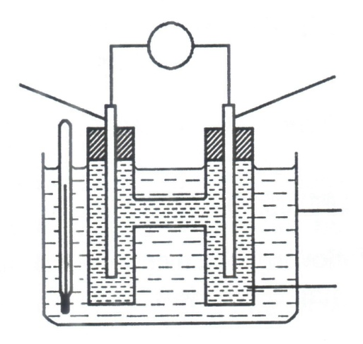  white tin  electrode II  thermostat tank  (NH₄)₂SnCl₆ (aq)  grey tin electrode I  V  Which of the following statements is true?
 | 1 | At 15 ºC, no current flows.
 | 2 | Below 15 ºC, electrons flow through the external circuit from I to II.
 | 3 | Increasing the size of the grey tin electrode will change the cell potential.

35 A reaction scheme starting from aqueous copper(II) chloride solution is shown below. Both G and H are copper–containing species.
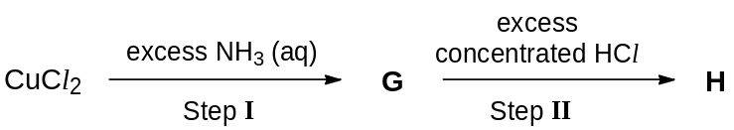

Which of the following statements is true?

1 G is a deep blue solution containing [Cu(NH₃)₄(H₂O)₂]Cl₂.
2 H is a yellow–green solution.
3 The intermediate in Step II is a blue precipitate.
The responses A to D should be selected on the basis of
A | B | C | D
1, 2 and 3  are correct | 1 and 2 only  are correct | 2 and 3 only  are correct | 1 only  is correct

No other combination of statements is used as a correct response.

36 Substances X, Y and Z react according to the following equation:
X(aq) + 2Y(aq) + Z(aq) ⎯→ products

Two sets of separate experiments are performed in order to determine the rate equation. The results are shown below:
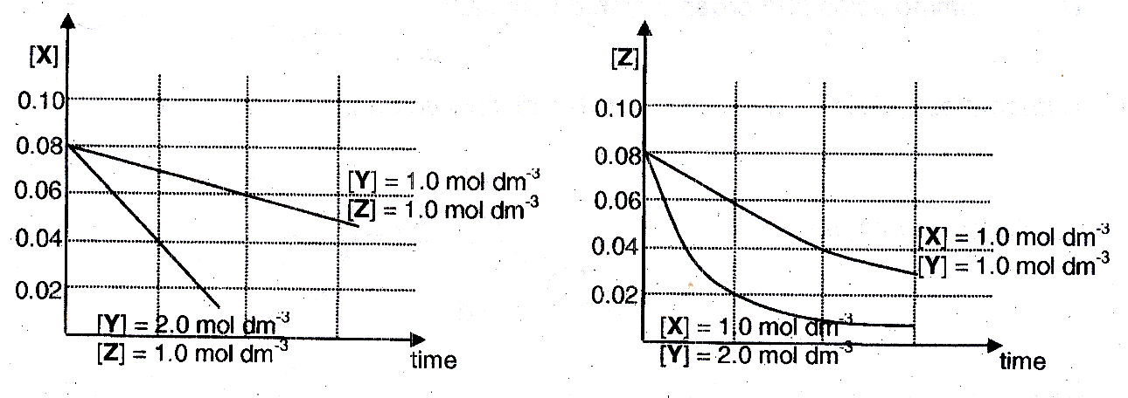
Which of the following statements is true?

1 | For this reaction, the rate equation is based on the overall equation.
2 | The order of reaction with respect to Y and Z are 2 and 1 respectively.
3 | Changes in [X] have no effect on the rate of reaction.

37 | For the reaction: (CH₃)₃SiCl + C₂H₅O– ⎯→ (CH₃)₃SiOC₂H₅ + Cl–  Which of the following statements are likely to be true?
 | 1 | It involves nucleophilic attack by C₂H₅O–.
 | 2 | Cl– is displaced by C₂H₅O–.
 | 3 | The oxygen–carbon bond is not broken.

38 | Which of the following is the same in both the optical isomers of lactic acid, CH₃CH(OH)COOH?
 | 1 | 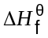
 | 2 | pK_{a}
 | 3 | boiling point
The responses A to D should be selected on the basis of
A | B | C | D
1, 2 and 3  are correct | 1 and 2 only  are correct | 2 and 3 only  are correct | 1 only  is correct

No other combination of statements is used as a correct response.

39 | The diagram shows some laboratory apparatus:  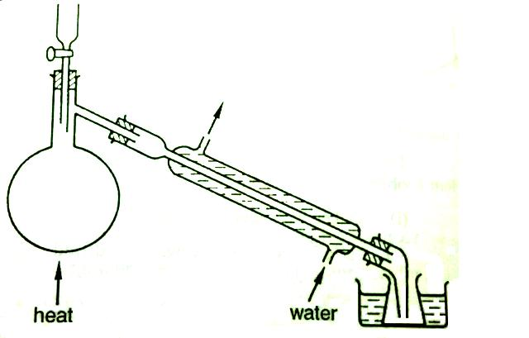  Which preparations could this apparatus be used for?
 | 1 | Bromoethane, from ethanol, sodium bromide and concentrated sulfuric acid.
 | 2 | Ethanal, from ethanol, sodium dichromate(VI) and sulfuric acid.
 | 3 | 1,2–dibromoethane, from bromine and ethene.

40 The use of Data Booklet is relevant to this question.

When exposed film from a camera is developed, one of the steps involves reacting the light–activated silver bromide crystals with aqueous alkaline hydroquinone.
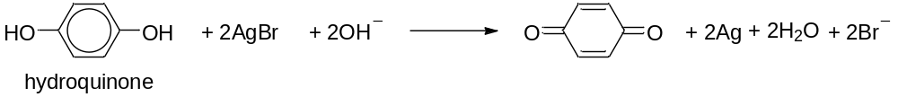

Which of the following statements is true?

 | 1 | This is a neutralisation reaction.
 | 2 | Both the organic reactant and product will decolourise aqueous potassium manganate(VII).
 | 3 | Hydroquinone acts as a reducing agent.

DHS H2 CHEMISTRY YEAR 6 PRELIMINARY EXAMINATION 2010
Paper 1 MCQ – Answers

1 | 2 | 3 | 4 | 5 | 6 | 7 | 8 | 9 | 10 |  | 11 | 12 | 13 | 14 | 15 | 16 | 17 | 18 | 19 | 20
C | A | D | D | D | D | A | B | C | C |  | A | B | C | D | C | A | D | C | D | B
21 | 22 | 23 | 24 | 25 | 26 | 27 | 28 | 29 | 30 |  | 31 | 32 | 33 | 34 | 35 | 36 | 37 | 38 | 39 | 40
B | C | D | C | A | B | D | B | A | C |  | B | C | B | D | A | C | A | A | B | A

